Should You Really Buy Bitcoin the Same Way Every Day?
Before starting this project, I had always assumed that the safest way to participate in Bitcoin was probably dollar-cost averaging.
It is simple, easy to stick with, and helps people avoid emotional decisions and the stress of market timing. But over time, I found myself coming back to one question:
Are all days really equally worth buying?
If DCA works mainly because Bitcoin trends upward over the long run, then uniform buying may not actually be the best answer.
That was the question my teammate Chenhao and I wanted to explore in this practicum: if the goal is not to predict price, but to improve the rhythm of long-term Bitcoin accumulation, can we do better than traditional DCA?

What matters is not “perfect prediction,” but smarter filtering
No model can reliably tell you where Bitcoin goes tomorrow. But that does not mean every day is equally attractive for accumulation. The real value, we found, lies in identifying which market environments offer better windows for long-term buying. From our analysis, four signal groups stood out.

1) The strongest signal is still on-chain: undervaluation plus participation
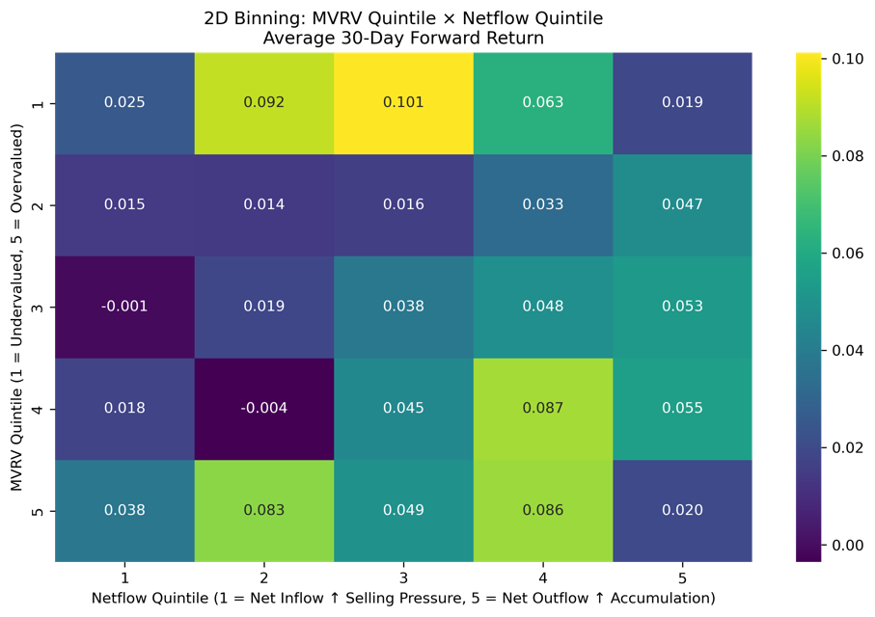
If I had to keep only one core finding, it would be this:
The best accumulation windows are usually not the moments of maximum panic, but periods when Bitcoin looks undervalued while network activity remains healthy.
More specifically, when Bitcoin is in a relatively undervalued regime, exchange netflows are positive on the outflow side, and active addresses remain elevated, forward 30-day performance tends to be stronger.
This is not quite the same as the common intuition that the best time to buy is simply when fear is most extreme. What the data suggests instead is a healthier kind of accumulation regime: price is not expensive, coins are leaving exchanges, and network participation has not collapsed.
It is less dramatic than “buying the absolute bottom,” but it may be more stable and more repeatable.

2) Polymarket is not great at predicting returns, but it is surprisingly useful for filtering risk
At first, we thought prediction market data might directly improve return forecasting.
What we found instead was that its stronger role is not return prediction, but risk filtering.
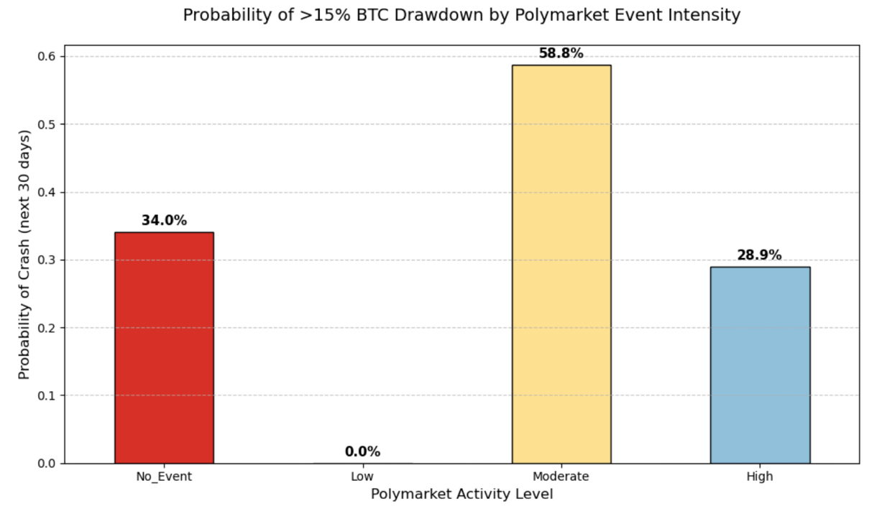
One pattern stood out clearly: when there is no meaningful macro event flow, no major information updates, and no strong narrative catalyst, downside risk for Bitcoin tends to be higher. By contrast, when the market is operating in a denser information environment, with participants actively repricing expectations around ongoing events, the probability of large forward drawdowns tends to be lower.
In other words, prediction markets may not be especially powerful at telling us how much Bitcoin will rise. But they do seem useful for telling us whether the market is still actively processing information.
That makes Polymarket less of a direct buy signal and more of an environment label. It helps answer a different question:
Is this a market where it makes sense to lean in, or one where it makes more sense to stay cautious?

3) “Smart money” signals look promising, but the evidence is still too limited
We also built a whale directional flow indicator to test whether large prediction market participants were moving in ways that anticipated future Bitcoin performance.
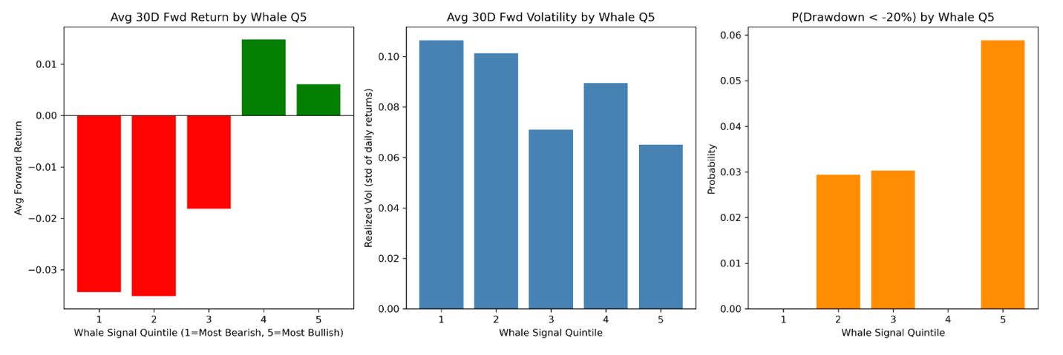
There was some signal there. Stronger whale flow tended to line up with better future returns and lower drawdown risk. But the historical coverage is still too short for us to treat this as a fully validated pillar of the framework.
For now, it looks more like a promising lead than a definitive conclusion.

4) The risk index behaves more like a thermometer than a steering wheel
We also constructed a Risk Index based on probability volatility in Polymarket, with the goal of measuring how quickly expectations were being revised.
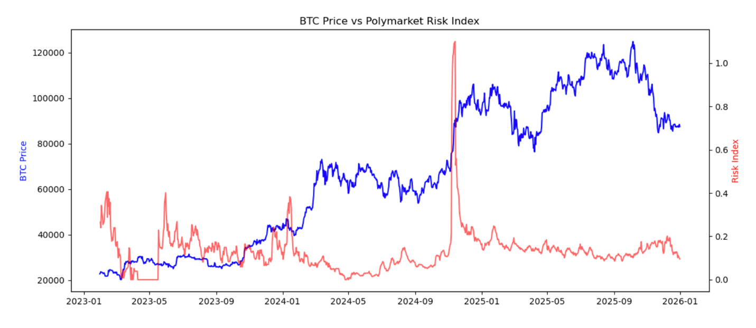
This index does a decent job of capturing the overall market environment, especially during periods of rapid narrative change or heavy political and macro event activity. But it behaves more like a coincident context signal than a leading market signal.
So in the final framework, we treated it more as a regime modifier than a primary driver. It is useful for reading the temperature of the market, but not for steering the entire strategy on its own.

So what did the final model actually do?
Rather than building a black-box model, we used a transparent layered framework:
- use on-chain valuation as the primary anchor
- strengthen it with active churn
- filter exposure through event conditions and risk regime
- then apply smaller adjustments using prediction market signals
In rolling one-year backtests, this dynamic model showed relatively consistent improvement over uniform DCA.
- Win Rate: 67.77%
- Final Model Score: 65.38%
- Mean Relative Improvement: +21.26%
The most important takeaway is not simply that the model outperformed.
It is that Bitcoin accumulation can, in fact, move one step beyond purely mechanical DCA.
Not toward some fantasy of perfect timing, but toward a more informed allocation process that still respects the long-term discipline of accumulation.

Limitations matter
This project still has several important limitations.
First, parts of the Polymarket dataset, especially those related to large trader behavior, are still relatively short in history.
Second, the model weights are still rule-based rather than the product of a fully optimized parameter search.
Third, many of the relationships between prediction market signals and Bitcoin appear to be regime-level rather than stable direct forecasting relationships.
And fourth, backtest improvement does not automatically translate into real-world execution advantage. Market structure changes, and signals can decay.
For that reason, I see this project more as a solid research starting point than as a fully settled endpoint.

Maybe the real lesson is simpler
This project did not make me reject DCA.
If anything, it made me appreciate why it has lasted for so long. DCA works not only because it is simple, but because it protects people from emotion, overreaction, and the endless urge to wait for a “better” entry.
What changed is something else.
I started to question whether every day really deserves the same allocation.
And if the answer is no, then maybe what matters more than predicting price is something simpler: Bringing the same patience to better moments.

